

Read Recommend Project Proposal

**Group Name**: Fab 5

|  |  |  |  |
| --- | --- | --- | --- |
| **Member Name** | **Email** | **zID** | **Role** |
| Vandhana Visakamurthy | z5222191@ad.unsw.edu.au | z5222191 | Developer/ Scrum Master |
| Rong Zhang | z3456421@ad.unsw.edu.au | z3456421 | Developer |
| Yiligong | z5199285@ad.unsw.edu.au | z5199285 | Back end developer |
| Yu Han | z5219071@ad.unsw.edu.au | z5219071 | Developer |
| Yuehui Chu | z5180907@ad.unsw.edu.au | z5180907 | Developer |

**Introduction** **3**

**Problem Statement** **3**

**Background** **3**

**Product backlog** **4**

User stories for Users 5

Novel Functionality **8**

Sprint 1 9

Sprint 2 9

Sprint 3 9

**Project Schedule** **10**

**User storyboards** **12**

**System architecture** **12**

**Architecture Layers** **14**

Presentation layer 14

Business layer 14

Data layer 14

**References** **15**

# Introduction

Readers and book lovers are always looking for good platforms or websites to find good book recommendations and share their reading experience. Over the past two decades, there have been many such websites to provide the same services that have been needed by such users. However, there have been no new platforms in the past couple of years with nuanced search options and ones that cater to individual user tastes. Our goal is to design and develop a system that meets all the fundamental problem requirements while ensuring an enhanced user experience with an improved recommendation system.

# Problem Statement

The website must be a platform for readers to connect with like-minded readers and find new books to read. It should also allow readers to share their experiences and review books. Therefore, the reader must be able to login as a user to avail such services. The user must use his/her email and set a password to use the website. The user provides other information like age and gender to improve the recommendation experience. The user can search for books and view the summary and reviews of every book in the database. Users can create collections and customise them as named collections. Users can add books to these customisable collections and access them whenever. The user can also view other people’s recently added/read books. Users must be able to see the total number of readers a certain book has. Users can review and rate books out of five and the average of the ratings are recorded and displayed when the book is searched for. Based on the user’s selections, books must be recommended to the user of similar interest and with various recommendation modes. Apart from all of which, the user must be able to set a reading goal and a time period to achieve said goal.

# Background

Reading recommendation websites are a combination of virtual library and social network with functionality like recommendations to help users to target their interests in seconds. For traditional reading websites, users can keep track of the books they have read, they are reading and want to read. Besides, users can search any book based on different features like book title, author and ISBN. Since users want to share reviews, find people with same interests and more importantly discover next books they like, more and more websites like GoodReads, LibraryThing and Riffle provide their platform to help users to find their needs.

In GoodReads, LibraryThing, Riffle and some other websites, users can create their own personalised collections with names and descriptions which are open to other users. By doing this, the opportunity can be increased to find users’ interesting books from looking at other users’ bookshelves. From these websites, book lovers can find a community of people who have the same taste of books by joining different groups created by other users to share ideas. Instead of joining into groups, users can also read and write reviews to gain and share insights of books. If users want to set a goal of their reading, they can easily do by giving a number of how many books they want to read in the current year and GoodReads will keep track of users’ process of reading. When users want to get recommendations, there are different ways offered by these websites. One way is automatic recommendation which is done by system algorithms that will analyse the books users liked. For example, GoodReads will do recommendations based on more than 20 books users have read and the recommendations on Riffle are not only based on users’ past reads, but also who are users currently following. Another way is introducing different genres which contain books related to them and different communities or groups that can do a person to person recommendation. For example, in anobii, a group named book recommendations that can give users ideas once become a member.

The main drawbacks of previous websites are lack of recommendation flexibility and advanced search. Goodreads asks the new user to rate 20 books and recommend other books based on their interests. For new users, if they want to use this functionality, they have to think up 20 books they have read and search these books and rated them, which is time consuming. In many websites, search function is only limited in title, author and ISBN. What if users want to search books published in certain countries or written in certain languages, current websites do not have this functionality to help users get their needs met.

# Product backlog

Project objectives:

1. Able to keep track of books they have read in any collection on readers’ accounts.
2. Able to look through any collections (own or other users).
3. Able to write reviews and give ratings.
4. Able to view full details of any book including all reviews in any book collection.
5. Able to view multiple aggregate statistics, including the book's average rating when viewing full details of books.
6. Able to search for books by name, author, or mostly recently added books to readers collections.
7. Able to filter out books from search results that are under a given average rating.
8. Able to provide readers with multiple recommendation modes.

## User stories

|  |  |
| --- | --- |
| Objectives | Users Stories |
| 1. Able to keep track of books they have read in any collection on readers’ accounts. | As a user, I want to register an account so that I can use the services on this website. |
|  | As a user, I want to login into my account so that I can use the services on this website. |
|  | As a user, I want to create a book collection so that I can classify books. |
|  | As a user, I want to add a book to my collection so that I can keep track of books I have read. |
|  | As a user, I want to remove a book from my collections so that I don’t need to track that book I don’t like any more. |
|  | As a user, I want to look through all possible books I like so that I can find my favorite as soon as possible. |
|  | As a user, I want to be able to set a goal to read a certain number of books every month, based on my collections so I can read everything in my collection. |
|  | As a user, I want to browse some random books so that I can explore unknown books. |
| 1. Able to look through any collections (own or other users). | As a user, I want to view books from other users’ collections so that I know what other people are reading. |
|  | As a user, I want to access mine or other users’ collections including seeing the recently read top 10 books, so that I can find new books to try. |
|  | As a user, I want to browse some random collections so that I can explore unknown books. |
| 1. Able to write reviews and give ratings. | As a user, I want to write reviews for a given book, including leaving a rating out of 5 so that other users can know my thoughts about this book. |
| 1. Able to view full details of any book including all reviews in any book collection. | As a user, I want to view reviews from other people so that I can know what others think about this book. |
|  | As a user, I want to view the full details of any book (including all reviews and total count of the number of readers), in any book collection so that I can decide whether I would read the book. |
| 1. Able to view multiple aggregate statistics, including the book's average rating when viewing full details of books. | As a user, I want to be able to view aggregate statistics, including the average rating of the book so I know if the book is actually good. |
| 1. Able to search for books by name, author, or mostly recently added books to readers collections. | As a user, I want to search books by book name, author, countries and languages and filter out books that are under a given average rating so that I can find the book details. |
|  | As a user, I want to see the most searched hashtags so that I can read the popular books. |
| 1. Able to filter out books from search results that are under a given average rating. | As a user, I want to search books by book name, author, countries and languages and filter out books that are under a given average rating so that I can find the book details. |
| 1. Able to provide readers with multiple recommendation modes. | As a user, I want to view the recommendations by selecting a book and a recommendation mode so that I can easily find the books that I am interested in. |
|  | As a user, I want to read books which are similar to the books that I have read so that I do not need to search all of them. |
|  | As a user, I want to read books that are popular for my age/gender/occupation so that I can find my interests. |

## 

## Novel Functionality

***Describes how some of the defined user stories to be implemented provide novel functionality compared to existing systems***

The following user stories will provide novel functionalities compared to existing systems like Goodreads. It will overcome the drawbacks mentioned in the background section.

As a user, I want to search books by book name, author, countries and languages and filter out books that are under a given average rating so that I can find more prefered books.

As a user, I want to get a summary of books I read so that I can visually understand my reading experience in order to determine which kind of book can be read next.

As a user, I want to see the most searched hashtags so that I can read the popular books.

As a user, I want to read books which are similar to the books that I have read so that I do not need to search all of them.

As a user, I want to read books that are popular for my age/gender/occupation so that I can find my interests.

## Sprint 1

start date: week 3 15/06/2020

end date: week 5 1/07/2020

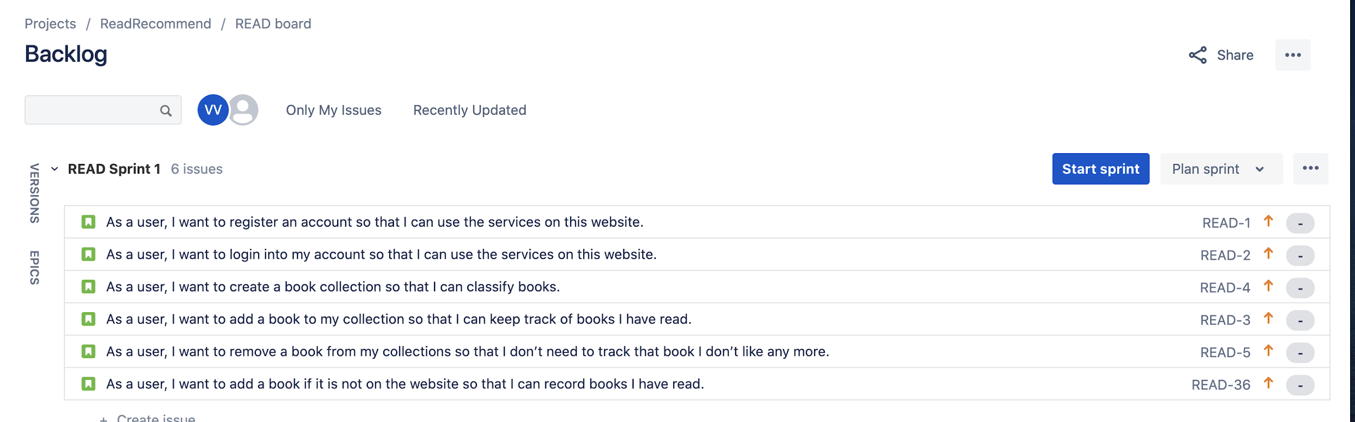

## Sprint 2

start date: week 5 2/07/2020

end date: week 8 22/07/2020

## Sprint 3

start date: week 8 23/07/2020

end date: week 9 31/07/2020

# Project Schedule

|  |  |  |  |
| --- | --- | --- | --- |
| **Week** | **Project Tasks** | **Start** | **End** |
| 1 | a. Make a group in Lab 1.  b. Register group in Webcms3, Jira, and GitHub.  c. Decide on a project topic.  d. Start writing a work diary.  e. Initial planning meeting. | 01/06 | 06/06 |
| 2 | a. Research on existing systems.  b. Decide user stories and initial sprint backlog.  c. Design system architecture and decide on various technologies.  d. Understand SCRUM usage. | 07/06 | 14/06 |
| 3 | a. Complete project proposal and submit by 21.06.2020.  b. Start initial sprint  c. Update report and documentation for the system. | 15/06 | 21/06 |
| 4 | a. Work on tasks specified in the initial sprint.  b. Monitor progress and track schedule.  c. Update report and documentation for the system. | 22/06 | 28/06 |
| 5 | a. Integrate and test the system from the initial sprint.  b. Progressive Demo A on 02.07.2020. | 29/06 | 05/07 |
| 6 | a. Start the second sprint.  b. Monitor progress and track schedule.  c. Update report and documentation for the system. | 06/07 | 12/07 |
| 7 | a. Monitor progress and track schedule.  b. Retrospective A outcomes on 16.07.2020. | 13/07 | 19/07 |
| 8 | a. Integrate and test the system from the second sprint.  b. Progressive Demo B on 23.07.2020. | 20/07 | 26/07 |
| 9 | a. Monitor progress and track schedule.  b. Retrospective B outcomes on 30.07.2020.  c. Software Quality Report on 31.07.2020. | 27/07 | 02/08 |
| 10 | a. Project Report Submission.  b. Final Project Demo.  c. Peer Assessment | 03/08 | 09/08 |

# User storyboards

Figure 1. User story boards

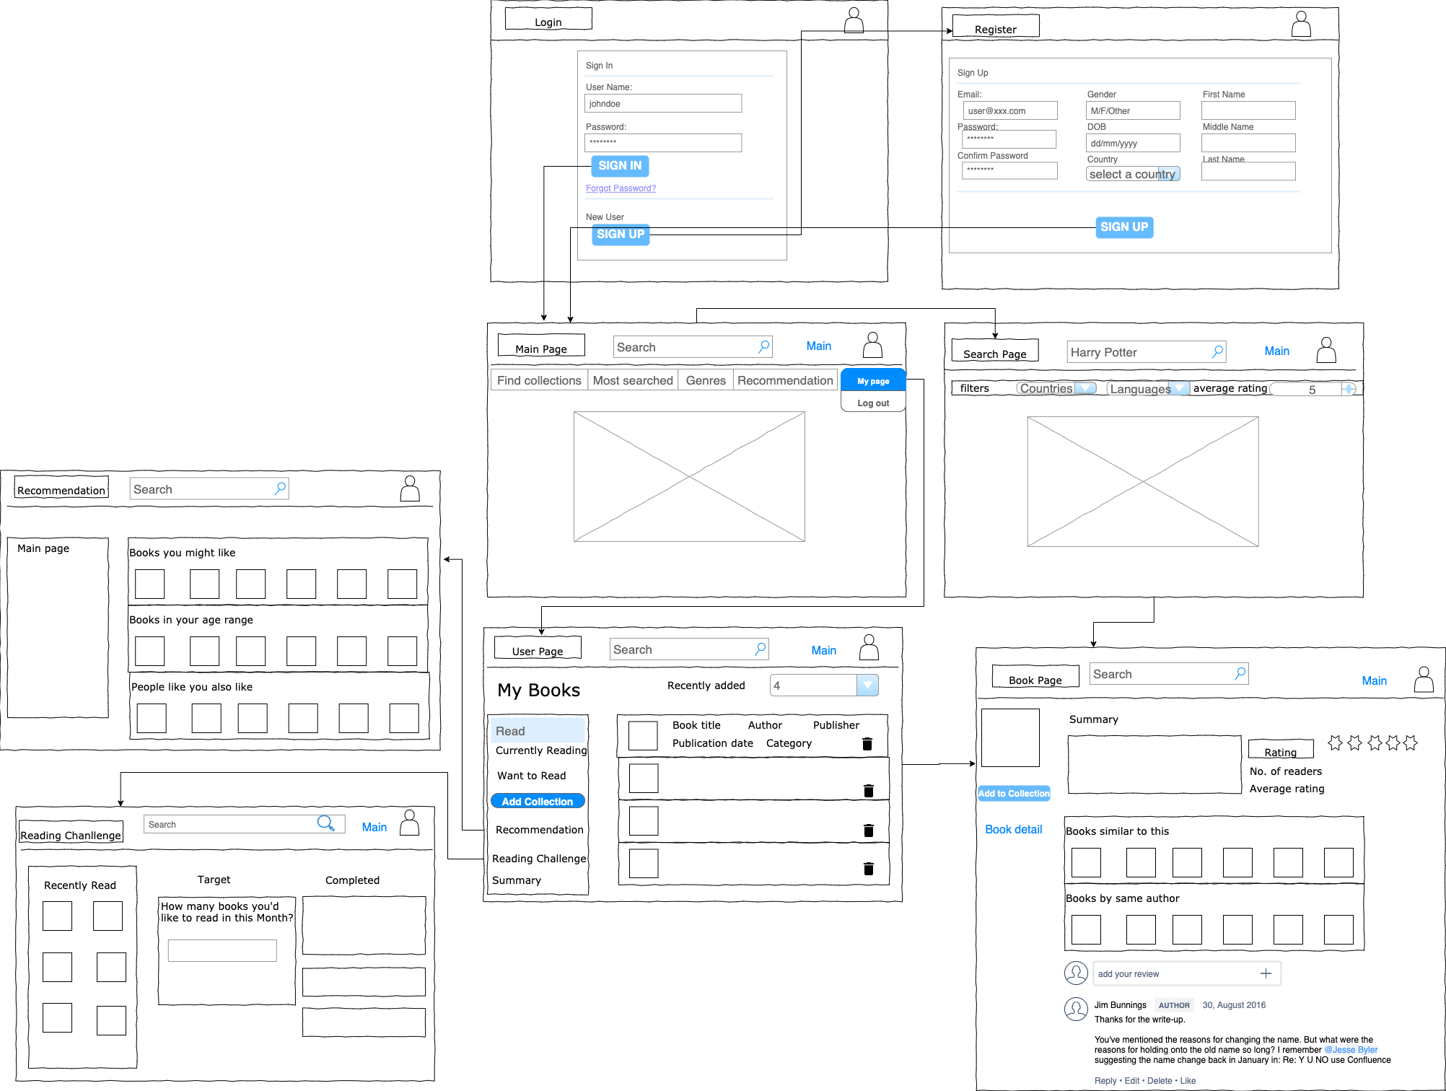

Figure 2. User Interface

# System architecture

***[A clear description showing the presentation, business and data layers in the system, and what each layer contains***

***A clear description of the external actors (eg: user types) and how they interact with the system***

***A clear description of the technologies/languages planned for use (eg: mysql, sql server, msmq, .NET, java, etc), including all third party functionality planned to be used (eg: clouds/services/APIs/libraries/code)]***

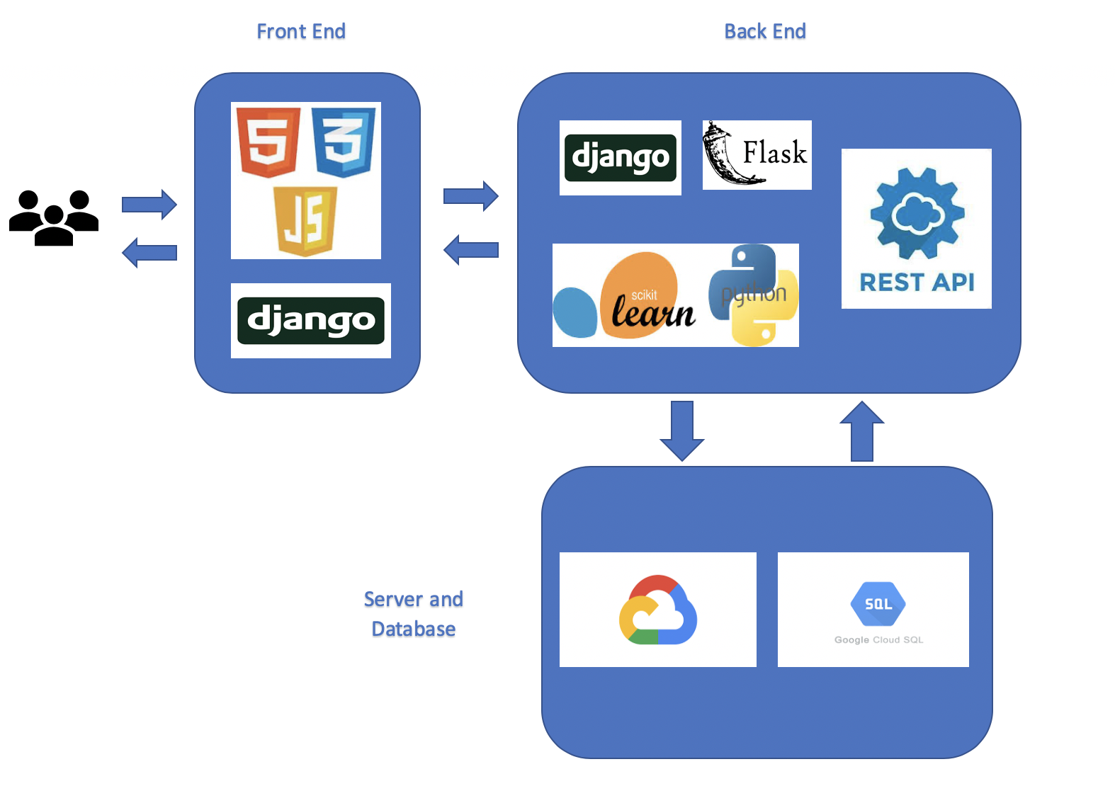

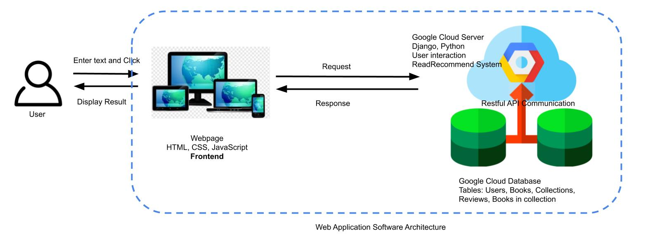

Figure 3. System Architecture. Platform description architecture and detailed web application architecture

**Frontend:**

HTML + CSS + JS + Django: For the frontend, we will use Django to manage framework. The view will consist of HTML webpage and CSS layout. The JavaScript will support some dynamic features.

**Backend:**

Database: Google Cloud Database

Server: Google Cloud Server

API: RESTful

Analytics: Google Cloud Analytics tools

Recommendation System: Machine Learning/Collaborative Filtering

In this project, we will host our backend on Google Cloud which is a reliable service that provides multiple features such as backend maintanese, activity monitoring, and server backup.

**Book Recommend System**

User-Book relationships – based on users’ individual book preferences (figure 4).

User-User relationships – based on similar people (i.e. people of a similar age, gender, occupation, etc.) likely having similar book preferences (figure 5).

Book-Book relationships – based on similar or complementary products (e.g. “The Martian” and “Artemis”) that can be categorized into relevant groups (figure 6).

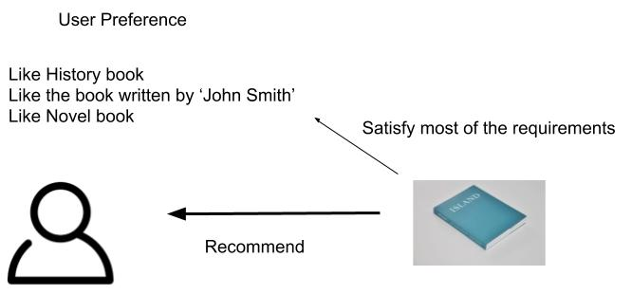.Figure 4: recommend the book based on user preference

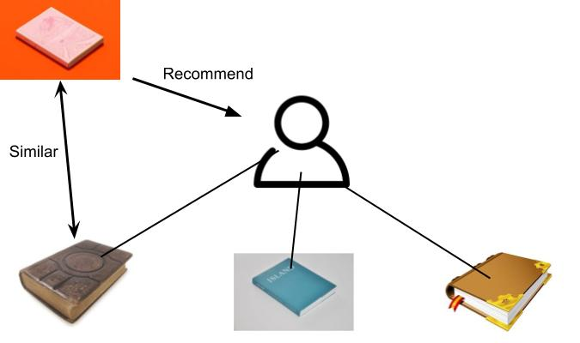

Figure 5: recommend the book based the similarity between the new book and read book

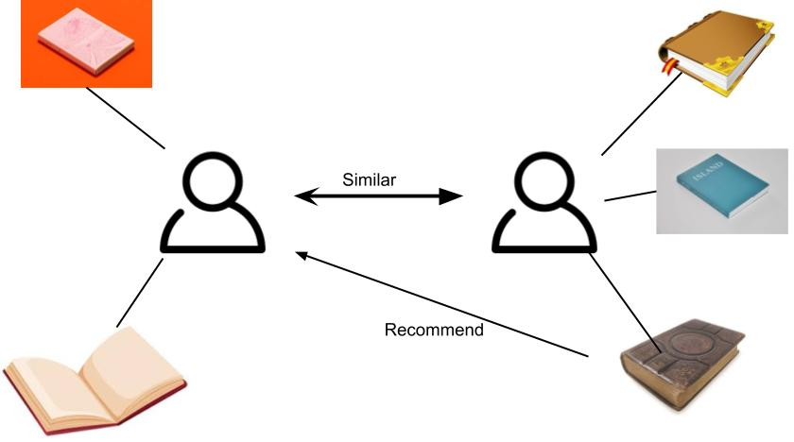

Figure 6: recommend the book based on the similarity between two users

# Architecture Layers

## Presentation layer

Users would use a web browser to access the service. Users can see the result on the web pages and interact by entering values in input fields and clicking buttons in order to use functions.

## Business layer

Django + Python Script: Django is a powerful frontend web tool with python. It can provide highly interactive web experience and comprehensive python libraries. By using python script, it can separate the front end and backend. It can handle the model and achieve data extraction, data storation, and recommendation systems. It connects presentation layer and data layer.

## Data layer

In this project, we choose google cloud SQL in order to store, analyse and extract books, collections, reviews, and users data. It is connected by the business layer.

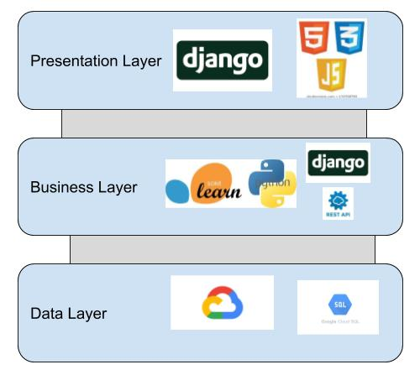

Figure 7: Layered Representation of the Architecture

# References

[1] <https://www.goodreads.com/>

[2] [https://www.librarything.com/](https://www.librarything.com/home)

[3] <https://www.rifflebooks.com/>

[4]<https://bookriot.com/2015/01/19/alternatives-to-goodreads-riffle-bookpedia-libib/>

[5]<https://turbofuture.com/internet/10-Sites-like-Goodreads-for-Authors-and-Readers>

[6]<https://www.lifehack.org/articles/technology/10-best-book-recommendation-sites-you-need-know.html>